 |  | 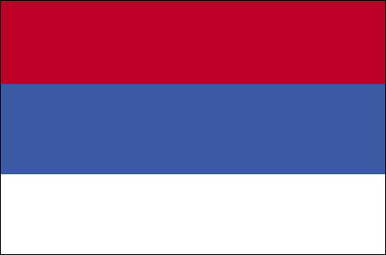
IPA Cross-Border Cooperation Bulgaria – Serbia Programme


The Ministry Of Regional Development and Public Works,
Republic of Bulgaria (Managing Authority)

in cooperation with

The Ministry of Finance,
Republic of Serbia (National Authority)

organizes

PARTNERSHIP FORUM

Dear Participants,

On 20 October 2009 a Partnership Forum for potential beneficiaries under the first Call for project proposals under the IPA Cross-Border Cooperation Programme between Bulgaria and Serbia will be organized in the city of Pirot.
The Call for proposals is published on the Internet site of the Programme: http://www.ipacbc-bgrs.eu/.
Those who are willing to participate in the Forum should fill in an individual registration form (annexed to the present call) and send it to the following e-mail:
ipacbc-bgrs@bbt.bg

DEADLINE FOR REGISTRATION – 13 October 2009

The Partnership Forum is organized with the financial support under BG 2006/018-388.01.03.01 project “Technical support for the future Cross-border programme between Bulgaria and Serbia”.

